GMAS/OAIR Integration
The January 18, 2021 GMAS release included integration between the Outside Activity and Interest Reporting system (OAIR) and GMAS. This document covers the following in relation to this new approval in GMAS.

Cut-over
FAQs
OAIR Approvals on Projects
Anatomy of the OAIR Approval in GMAS
OAIR Approval Statuses in GMAS
GMAS and OAIR Interface Timings
Glossary
Helpful Links

Cut-over
Projects that did not require identification of Investigators prior to January 16, 2021 (non-HMS projects with non-PHS+ sponsors) will continue to not require the identification of investigators and will not generate OAIR approvals.

All pre-existing COI and OAR approvals have been retired. The approvals will remain in the status they were in as of the end of business on January 15, 2021. These approvals will not appear as needed on the segment home page and will appear on the approval list screen at the bottom of the page in the Legacy section. The approvals will no longer have their own screens, but all documentation and comments will be accessible from the approval list screen.

Investigators added to research teams on new projects and projects previously generating OAR and COI approvals after January 15, 2021 will generate OAIR approvals in GMAS. Effective January 25, 2021, OAIR started sending notifications to investigators that generated OAIR approvals in GMAS during the cutover period to indicate that they need to complete a research certification in OAIR.

Please contact the GMAS help desk at contactgmas@harvard.edu or the OAIR helpdesk at oairhelp@harvard.edu if you have any concerns about approval generation during this timeframe.

FAQs
What does the OAIR acronym mean?
- OAIR stands for Outside Activity and Interest Reporting.

Why is the OAIR approval "Pending"?
- The initial OAIR approval status of "Pending" means the approval is waiting to be sent to OAIR to create or update a researched based cert. There could be a few reasons for the approval being in this status. To be sent to OAIR the investigator must have a HUID and an active PeopleSoft flag. The HUID must also exist in OAIR.
  - HUID in GMAS: If the investigator has not been set up with a HUID yet (approval status will state “non-HUID”), once the HUID record is sent to GMAS, the central office will need to perform a Person Merge to combine the HUID and non-HUID record. Once this is complete, the record will be sent to OAIR. For instructions on how to merge person profiles, see the Merging Person Profiles job aid.
  - PeopleSoft flag: If the flag is inactive (“No”), until the investigator obtains a new appointment the approval will not be sent to OAIR. The flag can be found on the person GMAS profile in the “Active in PeopleSoft” column in the “Person information” panel.
  - HUID in OAIR: The person record must exist in OAIR. Once the investigator is set up in MIDAS, the record should feed to both GMAS and OAIR. If you know the record is active in MIDAS and the approval is still Pending, please contact the GMAS help desk at contactgmas@harvard.edu.

I just added an investigator to the research team, and I see their OAIR approval "Pending". When will I see the cert in OAIR?
- Given all the scenarios in the “Why is the OAIR approval ‘Pending’” question above have been met, the OAIR approvals will create certs on the following schedule: At quarter past the hour every Monday through Friday from 8AM to 6PM EST.

I just edited some of the research team on an active project. Why didn't all investigators generate OAIR approvals?
- Investigators who are added on the active projects that existed prior to OAIR implementation will generate OAIR approvals. For example, if a continuation request is created on a project that was active prior to the OAIR implementation, and only one investigator profile on the research team was added (whether it is a new team member added as an investigator, or a non-investigator changed to an investigator) and saved, only that investigator will generate an OAIR approval.
Who notifies the investigators they have a certification to complete?
- OAIR will send all notifications to investigators. The investigator will receive an email from oair@harvard.edu with a link to the research certification for that project.

What does “processing in OAIR”, or “pending update” mean? Can the proposal be submitted?
- When the OAIR approval status is “processing in OAIR”, it means that a research certification was generated in OAIR and sent to the Investigator to be completed. The research certification is not completed yet. All research certifications must be submitted for review in OAIR or on file from the last twelve months prior to the proposal being submitted.
- When the OAIR approval status is “pending update”, it means that an event occurred (either notice logged for the first time, or an at-risk request authorized on a pending segment) that requires a re-check of the research certification status and potentially review in OAIR. Proposals should not be submitted, and awards should not be set up while OAIR approvals are in a “pending update” status.

How can I view the date of the last disclosure to determine if information is on file?
- OAIR sends basic status information to GMAS so it can be viewed on each disclosure. There is no longer a need to assess any particular certification or disclosure date or status.
- The OAIR application will assess the previous “on file” or “needs review” information so that simply “Done” or “Processing in OAIR” are displayed for reference and next steps can be determined.
- Click the "Update OAIR status" button on the Approval List screen to view the most current status information from OAIR.

When can the proposal be submitted?
- A proposal can be submitted when the approval statuses for all the OAIR approvals are “done”. It may also be ok to submit a proposal if OAIR statuses are “withdrawn”, or “withdrawn from OAIR”. Withdrawn indicates that the individual was changed to a non-investigator in GMAS and an OAIR approval is no longer required. Withdrawn from OAIR indicates that the research certification was withdrawn in OAIR. If in "Withdrawn from OAIR” status, please check with your local OAIR representative to ensure a new OAIR approval does not need to be generated. If a new OAIR approval needs to be generated, edit the research team member to generate or reach out to contactgmas@harvard.edu for assistance.
- See the “OAIR Approval Statuses in GMAS” section below for more information.

I’m looking at the Approvals in GMAS and an Investigator told me they just completed the research certification. How can I verify this?
- Click the "Update OAIR status" button on the Approval List screen. If the Investigator completed the requirement, GMAS can acquire that information instantaneously. The approval status should change from “Processing in OAIR” to “Done”. If it does not, email contactgmas@harvard.edu or oairhelp@harvard.edu.

The proposal got a great score. I want to get it ready for when the notice of award comes. Can I update the research team before the notice of award is received?
- Yes. After the grant is submitted, the research team can be confirmed and updated, but OAIR approvals will not move to “pending update” for a re-review of the research certifications until the first notice is logged or until an at-risk request is authorized.

We received the notice of award. Will the account be set up if the OAIR approval status for the PI is “pending update”?
- No. The award can only be set up when the OAIR statuses are “Done”, “Withdrawn”, or “Withdrawn from OAIR”. Please use caution when moving forward with OAIR approvals in “Withdrawn from OAIR” status. If unsure whether it is OK to proceed, please work with your local OAIR representative to ensure a new OAIR approval does not need to be generated. If a new OAIR approval needs to be generated, edit the research team member to generate or reach out to contactgmas@harvard.edu for assistance.

I added a TBD team member to my research team. Why don't I see an OAIR approval for them?
- TBD research team members do not get an OAIR approval. Once the TBD profile is changed to a person, the approval will be generated.

Why do I still see COI or OAR approvals on my project?
- COI and OAR approvals may show in the legacy section of the approval list screen for projects that existed prior to the January 2021 release. These approvals will be in the status they were in as of end of business January 15, 2021 and will not be editable. Comments can be added to the approvals if necessary.

OAIR Approvals on Projects
GMAS will generate OAIR approvals for all roles that are Investigators on the project (answering Yes to the questions highlighted below): 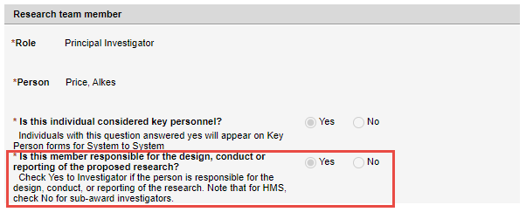
or
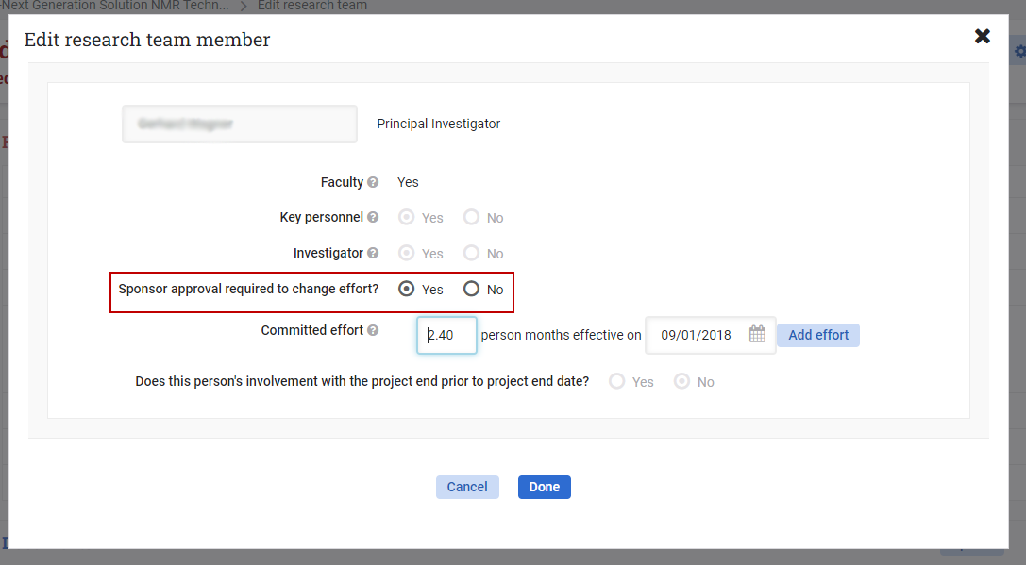
The PI will always be an Investigator; the selection option is not modifiable. All other roles will have the ability to select Yes or No for this question.

An Investigator can be added during the following events in GMAS:

On the Request
- Creating a new proposal
  - Adding the PI, Mentor (assuming the mentor is an investigator), and other investigators will generate OAIR approvals.
  - Initial Requests and Competing Renewals generate new approvals once the new request is set up.
  - Adding new investigators to the research team on Continuations or Supplements will generate approvals for those new investigators.
- Editing research team members
  - Changing the PI or Mentor
    - The new PI or Mentor (assuming the mentor is an investigator) will generate OAIR approvals.
      - Note: Changing the Mentor will default the Investigator flag to Yes for the new Mentor. Go to Edit the Personnel record to select No if appropriate.
    - The previous PI's or Mentor's approvals will be withdrawn from GMAS and if there is a certification associated to the record in OAIR, it will be Withdrawn or Retired in OAIR.
  - Editing personnel
    - Changing the Investigator flag from No to Yes will generate an approval.
      - Changing the flag from Yes to No will either delete the approval or withdraw the approval (if the individual is listed as an investigator on a prior request type), and if there is a certification associated to this record in OAIR, it will be Withdrawn or Retired.
    - Changing a TBD investigator to an individual (named) will generate an approval.
      - TBD will not initially generate an approval. The approval will be generated once an individual has been assigned to the role.
  - Deleting personnel
    - The approval for deleted investigators will be deleted from GMAS and if there is a certification associated to the record in OAIR, it will be Withdrawn or Retired in OAIR.
- Revise to Resubmit
  - All Investigators will receive new OAIR approvals when a Revise to Resubmit request is created.
  - The team for the Revise to Resubmit request will be copied from the request where the Revise to Resubmit was initiated.
  - To ensure the approvals and OAIR certifications are in the correct statuses, after awarding a Revise to Resubmit request, the prior version(s) should be closed.

Confirm research team request
- Adding new team members as Investigators will generate OAIR approvals.
  - OAIR approvals will be immediately generated.
- Confirming the team with investigators on it who do not currently have an OAIR approval (cutover) will generate OAIR approvals.
  - OAIR approvals will generate once the Confirm research team request has been finalized or awarded.
- Editing research team members
  - Changing the Investigator flag from No to Yes will immediately generate OAIR approvals.
  - Changing the flag from Yes to No will withdraw the approval in GMAS and if there is a certification associated to the record in OAIR, it will be Withdrawn or Retired in OAIR.
    - OAIR approvals will be set to Withdrawn once the Confirm research team request has been finalized or awarded.
- Deleting personnel
  - The approval for deleted investigators will be set to Withdrawn status in GMAS and if there is a certification associated to this record in OAIR, it will be Withdrawn or Retired in OAR.
  - OAIR approvals will be Deleted or Withdrawn once the Confirm research team request has been finalized or awarded.

At the Award Stage
- Adding new team members on Edit research team request as Investigators will generate OAIR approvals.
  - Adding new investigators on Supplements and Continuations will also generate OAIR approvals. Approvals for investigators added to those requests will not be visible on the segment until the request is awarded.
- Editing research team members
  - Changing the Investigator flag from No to Yes will generate an approval.
    - Changing the flag from Yes to No will be set to “Withdrawn” status in GMAS if generated on a request. If the approval was generated on the segment, it will be deleted from GMAS. If there is a certification associated to this record in OAIR, it will be Withdrawn or Retired in OAIR.
- Deleting personnel
  - The approval for deleted investigators will be set to “Withdrawn” status in GMAS if generated on a request and removed from a segment. If the approval was generated on the segment, it will be deleted from GMAS.
  - If there is a certification associated to this record in OAIR, it will be Withdrawn or Retired in OAIR.
- Changing the PI or Mentor in a segment revision
  - Changing the Mentor will default the Investigator flag to Yes for the new Mentor. Go to Edit the Personnel record to select No if appropriate.
  - The previous PI's or Mentor's approvals will be set to “Withdrawn” status in GMAS and if there is a certification associated to this record in OAIR, it will be Withdrawn or Retired in OAIR.

Anatomy of the OAIR Approval in GMAS
OAIR approval associated to a HUID profile: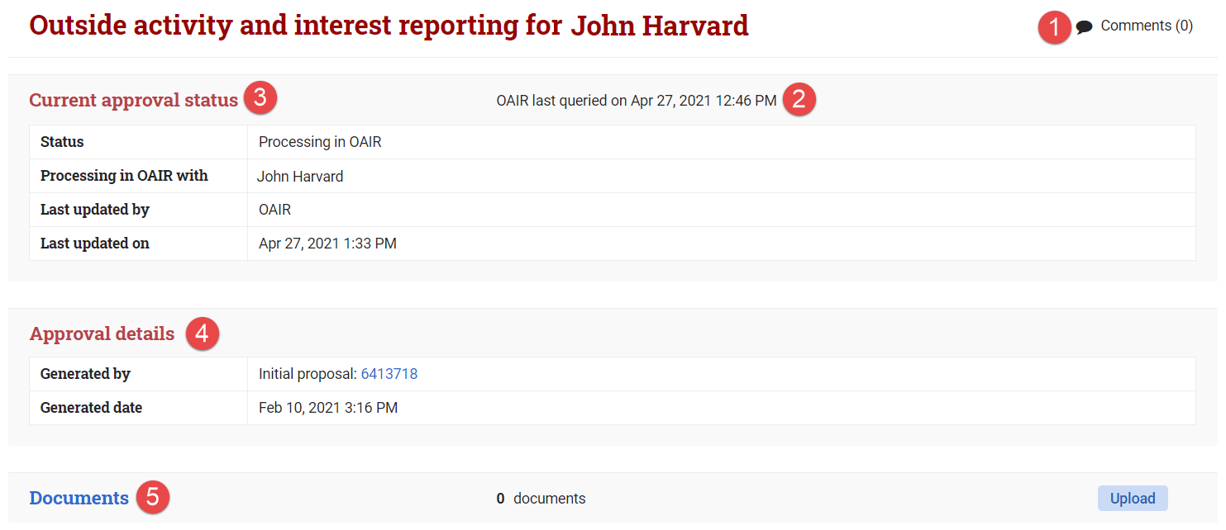
- Comments can be added from the approval list screen or from the approval screen. Comments added here will display from both areas.
- The approval screen will display the last date and time OAIR sent approval status information to GMAS.
- Current approval status data on the approval screen includes:
  - Status – Displays the current status of the approval. For definitions of statuses, see the OAIR Approval Statuses in GMAS below.
    - Processing in OAIR with – Only appears when the status is “Processing in OAIR” and indicates if the action to move the approval along is currently with the investigator or the OAIR reviewer.
  - Last updated by – Displays the system that last updated the status (will either show “GMAS” or “OAIR”). In the case of a non-HUID OAIR approval (see “OAIR approval associated to a non-HUID profile” below), the individual who changed a status to or from Pending will be displayed.
  - Last updated on – Displays the date and time the status was last updated on.
- Approval details on the approval screen includes:
  - Generated by – Displays where in the segment the approval was initially generated from. If generated from the segment research team, the project id will display and will not be a link. Approvals generated from any other location on the segment will link to that request or action memo.
  - Generated date – Displays the date and time that the approval was generated in GMAS.
- A document repository exists for all OAIR approvals. This document repository should not be used for housing confidential information related to the OAIR approval (that documentation should live in the OAIR system).
OAIR approval associated to a non-HUID profile:
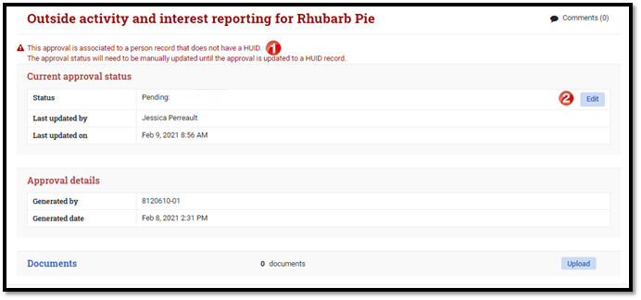
OAIR approvals associated to a non-HUID investigator have all the same fields as a HUID related OAIR approval. For information about these fields, refer to the anatomy of an “OAIR approval associated to a HUID profile” above. If an investigator has a HUID, a Central representative will need to perform a merge and delete so that the approval will be appropriately associated and sent to OAIR. For instructions on how to merge person profiles, see the Merging Person Profiles job aid.
- When an OAIR approval is associated to a non-HUID investigator, the approval screen will display a warning message indicating that the record will not automatically update and requires manual intervention. If the individual is a Harvard employee or affiliate and does have a HUID, then the wrong person profile may have been added to the research team and will need to be merged or replaced. Central administrators associated to this project in GMAS can assist with this process.
- When the OAIR approval is associated to a non-HUID investigator, the status can be manually updated by a Central Administrator, or an OAIR representative with the appropriate security to Done from Pending.
  - The edit button will only display for those who have the proper security, and when the approval is not in a “Withdrawn” status. When selected, the status field will display as a dropdown menu. The edit button will be replaced with a Cancel and Done button. Done must be selected for the status update to save properly. Both buttons will return the status field back to display only.

OAIR Approval Statuses in GMAS
Status | Description | OK to submit proposal or set up award?
Pending | Project and investigator information has not yet been sent to OAIR | 
Pending: non-HUID | Investigator information will not send to OAIR because it is associated to a non-HUID profile (these get managed manually until the profile is merged with a HUID)
Processing in OAIR | The research certification is being processed on the OAIR side and is not yet in a state where a proposal or award can move forward.
Pending update | The Research Certification requires additional review based on a major project milestone (award or at-risk) and project and investigator information has not yet been resent to OAIR.
Done | The research certification is in a state in OAIR where a proposal or award can move forward. | 
Done: non-HUID | This is a manually entered status for non-HUID OAIR approvals. Central users and OAIR representatives can update the OAIR approvals to this status from the approval screen.
Withdrawn | The investigator has been removed or updated to a non-investigator from the segment research team.
Withdrawn: non-HUID
Withdrawn from OAIR | The OAIR approval has been withdrawn on the OAIR side. When the approval is in this status a follow-up should happen with a local OAIR representative.

GMAS and OAIR Interface Timings
Send approvals OAIR:
- Every 60 minutes
- Monday to Friday 8AM to 6PM EST at quarter past the hour

Send “Pending update” approvals and updated project data to OAIR:
- Four times a day
  - Monday to Friday at 9AM, 12PM, 3PM, and 6PM

Send removals to OAIR:
- Four times a day
  - Monday to Friday at 9:45AM, 12:45PM, 3:45PM, 6:45PM

Get status updates from OAIR
- Every 60 minutes
- Monday to Friday 8AM to 6PM EST at half past the hour
- Ad hoc via "Update OAIR Statuses" button on the Approval List screen
  - This button will update the status for approvals on this screen only
  - The button is available only if there are OAIR approvals on the project in a status that indicates they have already been sent over to OAIR (“Done”, “Processing in OAIR”)

Glossary
OAIR: Outside Activity and Interest Reporting System
OAIR Representative: The person who manages the administrative process supported by OAIR or conducts the review of the certification in OAIR. This person is sometimes referred to as the COI Administrator.
Cert: Certifications in OAIR where investigators must disclose their relevant outside professional activities and interests along with any information about how these may or may not be related to the research with which they are being associated
COI: Conflict of Interest
OAR: Outside Activity Report

Helpful Links
GMAS 1_56 Release
https://ras.fss.harvard.edu/oair-job-aids

